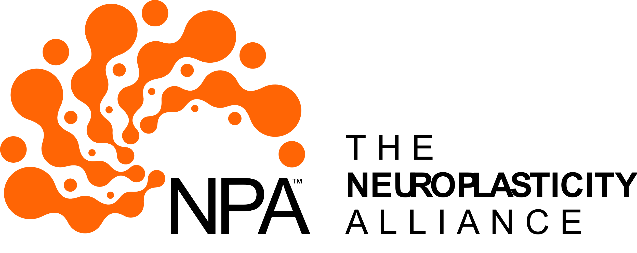

**Part-Time Chief Development Officer**

**20-25 Hours/Week  
Louisville, KY**

**Make an Impact with Neuroplasticity Alliance (NPA)!**

**Why The Neuroplasticity Alliance?**

Join us in sparking a national movement to transform the lives of individuals facing neurological dysfunction by tapping into the incredible power of the brain’s ability to rewire itself—this remarkable phenomenon is known as neuroplasticity.

Groundbreaking research reveals that the neurological challenges stemming from injuries, diseases, and developmental issues, impacting over 50% of our population, can not only be improved but in many cases even reversed through innovative therapies rooted in applied neuroplasticity. The Neuroplasticity Alliance is passionately dedicated to raising awareness and expanding access to these life-changing therapies, empowering individuals to reclaim their futures and embrace their full potential. Together, we can make a profound difference!

**About our Development Officer Position**

We are seeking a **senior, self-motivated Chief Development Officer (CDO)** with a proven track record of securing major gifts and building robust donor relationships within the healthcare sector. This **part-time role (20-25 hours/week)** is ideal for an experienced leader eager to harness their deep connections while enjoying a flexible schedule.

As CDO, you will spearhead donor cultivation, lead impactful fundraising initiatives, and forge strategic partnerships to establish and fuel NPA’s development and growth in Louisville, KY. In this pivotal position, you will focus on creating strong donor alliances, orchestrating high-impact fundraising events, and enhancing NPA’s visibility, offering a unique chance to make a lasting difference in the lives of people with neurological challenges.

The ideal candidate is someone with a **strategic mindset and entrepreneurial spirit** who will excel in the dynamic, hands-on role of helping shape a new organization. Be part of our inspiring journey! Join us to ignite a transformative movement in neurological care!

**Key Responsibilities**

**Donor Cultivation & Fundraising:**

* Build and manage a portfolio of mid- and major-level donors, serving as a front-line fundraiser to secure gifts.
* Prioritize donor cultivation, stewardship, and appreciation to foster lasting partnerships.
* Organize impactful fundraising events (e.g., galas, community outreach) to boost visibility.
* Collaborate with the Executive Director (ED) and Board to develop annual fundraising plans and strategies.

**Strategic Alliances:**

* Forge relationships with community partners, businesses, and foundations to enhance NPA’s mission.
* Educate stakeholders about neuroplasticity to drive fundraising success.
* Reporting: Monitor fundraising progress and prepare outcome reports for ED and Board.

**As We Grow:**As NPA expands, the CDO may opt to take on additional tasks, including:

* Personnel Management: Shape and lead a fundraising team, hiring passionate staff.
* Communications: Oversee proposals, grants, and donor materials.
* Board Relations: Support Board recruitment and fundraising committee efforts.
* Financial: Manage the Development department’s budget.
* Community Engagement: Lead broader community events and partnerships.

**Who You Are**

* Senior Expertise: 15+ years in nonprofit fundraising, with a proven track record in healthcare philanthropy and a strong network in Louisville. Added experience in Atlanta, GA a strong plus.
* Self-Driven: Entrepreneurial spirit, thriving in a hands-on role to scale a new venture.
* Connected: Ability to leverage existing relationships with donors, foundations, and civic leaders for quick impact.
* Mission-Focused: Committed to NPA’s vision of transforming neurological care.
* Flexible: Seeks a part-time role (20-25 hours/week) with schedule flexibility, ideal for a seasoned expert balancing lifestyle needs.

**Skills & Requirements**

* Experience securing major gifts and organizing fundraising events.
* Strong verbal/written communication and relationship-building skills.
* Proficient in Microsoft Office and CRMs.
* Self-starter with excellent prioritization and time management.
* Valid driver’s license; ability to travel locally in Louisville/KY (occasional overnight trips).
* Physical ability to lift up to 50 lbs., sit/stand for prolonged periods, and work outdoors occasionally.
* Four-year college degree preferred.

**Why This Role?**

* Impact: Use your expertise to revolutionize awareness of and access to recent discoveries in neuroscience, such as neuroplasticity-based therapies.
* Flexibility: Part-time (20-25 hours/week), remote with local travel, perfect for a senior leader seeking balance.
* Growth: Shape a new organization with potential to expand your role as NPA grows as desired.
* Competitive Pay: Negotiable salary/benefits based on credentials and experience.

**How to Apply**Send your resume and cover letter to sherry.odom@NPAllies.org. Join NPA and leverage your network to transform lives!

*Neuroplasticity Alliance (NPA) is a nonprofit empowering individuals with neurological challenges through education and advocacy.*